**Activities to Build ENGAGEMENT**

* Steve McQueen Dinner & Car Show to utilize skills taught on campus
* Warehousing course with Wreath Production
* Student Council
* Student government
* Pay crew positions
* CTE courses
* Masonry ROP
* Cottage of the week & month competitions
* Weekly Town Hall Meetings
* Graduation ceremonies as students complete graduation requirements
* Fieldtrips
* Schoolwide equity and inclusion days
* Intramural sports
* Weekly awards

**Chino Valley Unified**

**School District**

**What is Home-School Partnerships?**

Home-School Partnerships is an agreement that parents, students and teachers develop together. It explains how parents and teachers will work together to make sure all students reach or exceed grade-level standards.

Effective compacts:

* **Link** to goals of the school's single plan for student achievement
* **Focus** on student learning skills
* **Describe** how teachers will help students develop those skills using high-quality curriculum and effective instruction in a supportive learning environment
* **Share** strategies parents can use at home
* **Explain** how teachers and parents will communicate about student progress
* **Describe** opportunities for parents to volunteer, observe, and participate in the classroom

**PARTNERSHIPS FAMILY PARTICIPATION**

**HOME-SCHOOL PARTNERSHIPS**

**for**

**STUDENT ACHIEVEMENT**

**2022-2023**

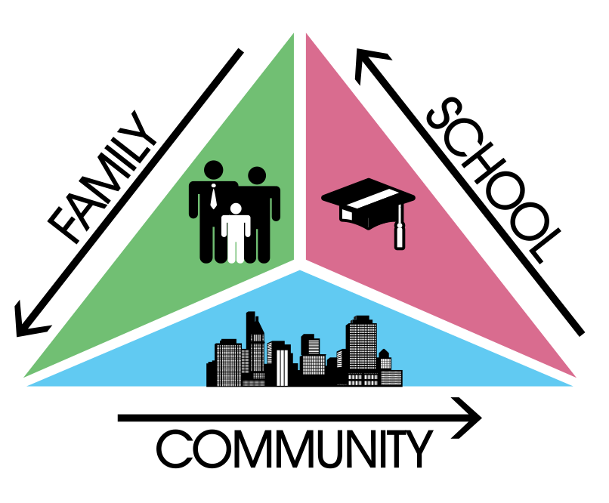

***Grade levels: 9 - 12***

**“Nothing Without Labor”**

**(BOYS REPUBLIC HIGH SCHOOL)**

1907 Boys Republic Dr.

Chino Hills, CA 91709

(909)628-1217 ext. 212



**Learning Compact**

**Communication about Student Learning**

Our school and families are committed to regular two-way communication about our children’s' learning. Some of the ways families and staff communicate all year are:

* **School to Home**
  + weekly academic & behavior grades
  + daily feed back with positives negatives, phone calls, OCs & emails
  + school website
* **Home to School**
  + walk arounds by cottage staff
  + email
  + cottage staff-teacher meetings
  + follow up on grades, negatives, OCs, phone calls, & emails

***https://www.chino.k12.ca.us/Dickey***

**DISTRICT PARENT RESOURCES**

**Family Engagement Center**

**Adult School, Room 25**

**12970 Third St. Chino, CA 91710**

***WORKSHOPS PROVIDED:***

***EL PARENT ACADEMY***

***12 POWERS OF FAMILY BUSINESS***

***PARENTS AS PARTNERS***

***TRANSITIONS TO…..***

***COMPUTER LITERACY***

***FAMILY LITERACY PROJECT-COLLEGE AWARENESS***

**Family Engagement Center Link:**

**http://www.chino.k12.ca.us/Page/8882**

**909 628-1201 ext. 5601**

**(Spanish) 909 628-1201 ext. 5602**

**At the Cottage**

**Here are some ideas of how families can support students’ success:**

* Follow up with students on weekly grades
* Follow up with teachers if the student earns a below average weekly grade
* Encourage students to earn a 3 or 4 on the academic weekly grade
* Hold students accountable if they earn a 0 or 1 on the academic weekly grade
* Hold students accountable if they receive a U or N for the weekly citizenship grade
* Use the 35 Day Progress Report to measure student success in the first 7 weeks of his program
* Encourage students to earn a credit every three weeks in each of their classes
* Check on students in classes at least weekly
* Conference with teacher when there are concerns
* Create a culture of success and effort by stressing the institutions and the schools motto, “Nothing Without Labor”

**In the Classroom**

**As a BRHS teacher, I will engage all students with a vibrant learning climate and high-quality instruction. Listed below are some of the student learning strategies your child will use this year.**

* Use of high interest curriculum, allowing students to work at their own pace to become credit current, approach becoming credit current, or graduate from high school
* Use of a seven period schedule to facilitate students earning additional credit
* Use of the APEX computer curriculum to aide learning and acquisition of credit.
* Use of the GED program to assists seniors who are far behind in credit
* Use of the Read 180 program for students far below grade level reading
* Special Ed. Teachers to assist students with IEPs
* Notify cottage staff of student’s academic progress through weekly grades, emails, phone calls, negatives, positives, phone calls and during staff walk arounds.
* CTE courses to allow skills acquisition by students, allowing them to lead a law abiding and productive life within the community.
* Weekly awards ceremony to reward and encourage student achievement

**Learning Compact**

**Teachers, Parent, Guardian, Students Shared Responsibility for Learning**

**District Goals - Local Control Accountability Plan (LCAP)**

All students are provided a high-quality teaching and learning environment.

Staff, parents, families, and students are connected and engaged at their school to ensure student success.

All students are prepared for college and career beyond graduation.

**School Goals**

**GOAL 1 –** BRHS provides staff with high quality professional development to address the unique needs of Boys Republic students

**GOAL** 2 – All students will receive an Individualized Learning Plan (ILP) to increase credit recover, earning a HSD, or a GED.

**GOAL** 3 – Students will be enrolled into intervention courses to facilitate earning credit and gaining academic skills.

*Our school provides high quality curriculum and instruction in supportive and effective classroom environments to enable students to meet state academic standards. We support our students and work hard to provide a welcoming, safe school environment.*

**Our Goals for**

**Student Achievement**